Hippogriff

Final Proposal

As Prepared by the Ministry of Magic’s Statute of Secrecy Committee:

Tiffany Lau

Vivian Nguyen

Michael Si

Maxwell Wu

ME 112 Mechanical System Design

Winter 2012

Stanford University

**Executive Summary**

Our objective was to design and build a baby hippogriff powered by a DC motor and operated on batteries to traverse both flat surfaces and a 10 degree incline. Resembling a hippogriff in both structure and gait, it’s motion had to be powered by mechanical devices, and it had to move quickly (at least 1 meter in 15 seconds).

After using MATLAB to create coupler curves and determine the lengths of linkages that would best imitate the gait of a hippogriff, we built several iterations of the same linkage design but altered the placement of axles, the assembly method, and lengths of the slider crank to drive the wing movement.

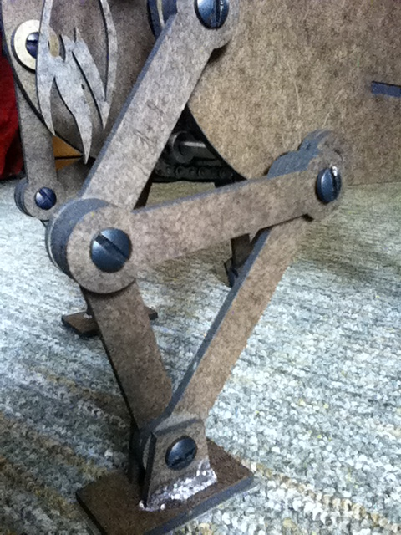

Our final design consisted of the same 4-bar linkage for each leg, with opposing legs offset to imitate the gait of a horse (see Figure 1, left). Our design also consisted of a slider crank driving the wing movement. Each pair of legs and wings is driven by axles with sprockets connected to the motor with a metal gear chain (see Figure 2, below). We used a 12V, 306 mA geared motor with a d-shaped shaft, to which we secured a sprocket onto with a set screw. This sprocket was then be connected to one axle of legs, which is connected to the other axle of legs, to which is connected to the wing axle.

**Figure 1 (left): Hippogriff leg made of four bar linkage.**

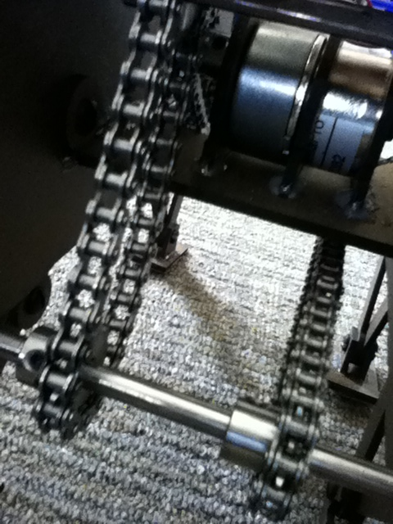The materials used for the hippogriff are: lasercut masonite, plastic screw pins, d-shaped steel axles, metal sprockets, metal gear chain, and the motor with accompanying batteries and wires to power it. The head, wings, and tail are masonite outlines of the form to reduce the weight and the motor is in the middle of the motor to ensure that the center of gravity doesn’t upset the balance of the machine.

**Figure 2 (right): Sprocket/chain drive connected to motor**

To test the linkages and analyze the movement, we coded them in MATLAB and conducted the torque analyses below. We were able to determine the linkage system from these analyses but did not take factors such as friction, ease of fluid movement, how all the mechanisms fit on the 9-inch length body, the amount of torque needed to drive the machine into consideration until we build the prototype.

After building the prototype, we realized that there was a few crucial elements that needed to be addressed: (1) providing enough contact surface and friction on the feet so that the hippogriff could move, (2) rearranging and redoing lengths of linkages so that they would all fit on the body, (3) securing the motor tightly enough to the body so that it would not move when powered, and (4) providing enough voltage to the motor so that there is enough torque that the hippogriff would move and the motor would not stall.

**Torque analysis form virtual work**

After many trials by using MATLAB simulation, we have chosen a set of parameters for our four bar linkage mechanism that produces a coupler curve of our desired shape. The parameters and the coupler curves are shown below:

|  |  |  |  |  |  |  |
| --- | --- | --- | --- | --- | --- | --- |
| **R1** | **R2** | **R3** | **R4** | **R5** | **θ1** | **Ψc** |
| **3.00** | **0.85** | **3.25** | **3.00** | **4.00** | **0.80π** | **π/6** |

As demonstrated by the coupler curve (see Figure 3 below), this four bar linkage indicates smooth movement of the feet as they push against the ground and quick return effect as they retract and repeat the motion. The same coupler curve with smaller y increments allows us to examine the motion more closely.

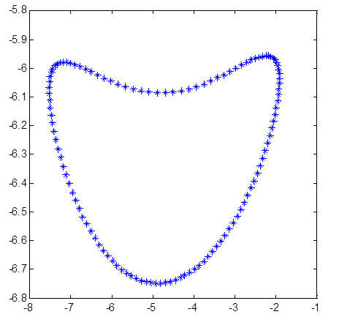

Figure 3- Coupler Curve with Small Y Increments

The corresponding x- and y-velocity curves are also generated based on the parameters we used above (see Figures 4 & 5 on the following page)





**Figures 4 & 5 (above): X & Y velocity curves**

Under the assumption that the maximum torque would reach when the leg is pushing the body upward against the ground, i.e., the y-velocity reaches maximum magnitude, the power needed can be obtained by:

Where

F = resistive force, i.e., weight of hippogriff (N)

v = coupler speed (m/s)

τ = motor torque (Nm)

ω = rotational speed of motor shaft (rad/s)

With an estimated weight of 500g, we have:

**2**

From the y-velocity curve, we can find the maximum y-speed (cm/s) of the coupler to be:

The current values of R1 to R5 used have been scaled by ½ from our original trial values in order to keep the body compact, and hence:

and

max

To make sure that our hippogriff will complete a 1-meter distance within 15 seconds, the minimum speed of the hippogriff is 0.07 m/s, which corresponds to a rotational speed of 2π rad/s for the motor shaft. In this case, the maximum power needed would be 0.25 W. At any given time, at least three legs are touching the ground and supporting the body. Thus, we determined a motor that can provide 10 Ncm of torque and operate at 120-180 RPM at maximum efficiency is sufficient. After comparing among motors with different specifications on McMaster-Carr catalog, we decided to use a motor that runs at 8.3Ncm (850 g-cm) and 145 RPM at top efficiency and a nominal voltage of 12V.

**Predictions with multiple legs**

To have our hippogriff produce a walking motion, we needed to offset each leg by an amount. By offsetting the legs’ motions compared to one another, we could have a few feet on the ground while another one lifts up and makes a stride forward. Since we also wanted to simulate a horse’s gait on the hippogriff, we tried to have the diagonally opposite legs move closely together, while the front legs would have an offset of 180°. By having this offset, the legs would be on different parts of the coupler curve for any given moment in time. We hoped that the two or three lowest points of the legs on the coupler curves would be the ones touching the ground, while the highest one would be moving forward in a stride.

The hope that we would have three legs on the ground at any given time inspired us to find a coupler curve with a slow pushback and a quick return, while also having the pushback section relatively flat so that the hippogriff would not be imbalanced. From these goals, we created the linkage from the previous section. It features both the quick return and a relatively flat coupler curve, which allowed our hippogriff to be relatively balanced and have good strides due to the longer time spent in the bottom section of the coupler curve. In the final hippogriff, we offset our front and back sets of legs by approximately 75°, which turned out well for moving forward and also up the slope.

**Results from Testing**

Although our virtual analysis looked promising, implementing it in a real prototype unearthed unforeseen problems. Our coupler curves showed a quick return and a slight upward lift from the lower parts of the curve where the leg is supposed to come off the ground and then set itself down again and push forward. We also decided that our hippogriff should try to imitate a horse’s gait by moving diagonal legs together, or shortly after each other. However, our prototype testing proved that the hippogriff would not work immediately as we planned from our analysis. The major problems that we found in our first few hippogriff prototypes were that the legs would slip due to little friction, imbalance of weight, and the shifting of the weight.

Our first fully built hippogriff would not run well because it was unable to move forward. Although the legs moved as they were supposed to, they could not push the hippogriff forward due to the lack of friction with the ground. Until we added in friction by adding Masonite feet, which were flat pieces that provided more surface area, and varying sources of friction, the hippogriff prototype only managed to walk in place. After attaching feet, it started moving forward, although it clearly had signs of slipping. To increase the friction, we considered a hot glue layer, sandpaper, and rubber. We only managed to test the hot glue and sandpaper, which both worked to a certain degree. Our final hippogriff had two feet with sandpaper, and two feet with a hot glue layer. Although it still slipped while going up a slope, it did not show signs of slipping on flat ground and still managed to slowly climb the slope.

Secondly, another apparent problem in the first iterations of our hippogriff was the imbalance of weight that caused it to veer away from a straight line. Our first prototype would always go towards its left, which is the side the motor was mounted on. The weight imbalance may have caused the hippogriff’s left side to deal with extra weight, which could force the heavier side to have its leg touch the ground earlier and result in a smaller stride. In the end, we shifted the motor closer to the center and tried to balance the weight as evenly as possible.

The last problem we didn’t expect from our analysis was the shifting of the weight distribution as it moved. This caused our hippogriff to move unsteadily, as the weight shifted from side to side. The shifting was apparent in all of our iterations, although rebuilding it in our final version as cleanly and polished as possible helped to minimize the impacts of this problem. Although the impacts of the shifting decreased from our first iterations, we believe that it was still the problem that caused our hippogriff to veer off course.

**Conclusions**

From our various analyses and prototyping, we were able to arrive at a series of conclusions:

1. Four bar linkage simulations in MATLAB: Our coupler curves indicated our four bar linkage would have smooth, continuous movement with quick return followed by a modest upward lift. In combination with offsetting opposing legs by 180 degrees, our hippogriff’s gait was able to somewhat resemble the gait of a horse/hippogriff. Our strong coupler curve ultimately saved us from having to iterate our final leg design in regards to leg movements.
2. Torque Analysis: Our torque analysis allowed us to determine the best motor for use with our hippogriff for maximum efficiency.
3. 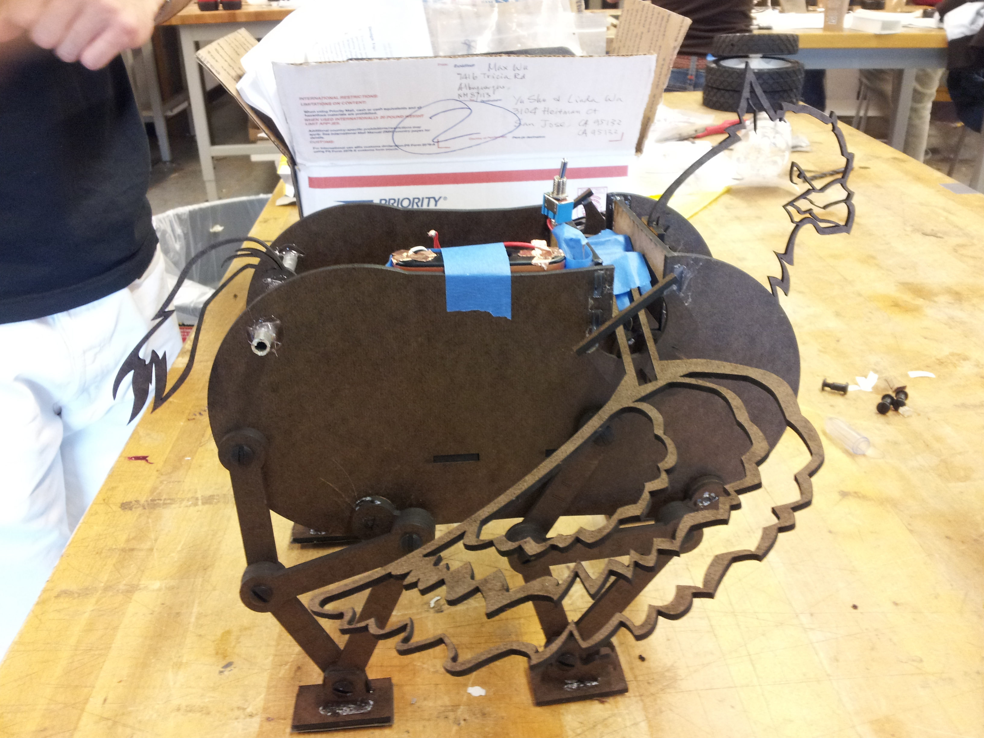Prototyping: While our motor was powerful enough for our hippogriff to travel the required flat distance within the time requirements, the torque was not substantial enough for our hippogriff to surmount the 10 degree grade traversal. During prototyping, we tried a variety of solutions; adding a larger surface area on the bottom of the hippogriff’s feet for increased traction, further increasing traction by adding hot glue and/or sandpaper to the bottom of the feet. Ultimately, we settled on sandpaper on only the back legs and hot glue on the front legs. Despite these changes, our hippogriff was still unable to overcome the torque required to ascend the grade. As a result, we increased the voltage from one 9V battery to two 6V batteries in series. We also found our hippogriff did not travel in a straight line, as a result of unevenly distributed weight which affected the gait and direction of our hippogriff. To address this issue, we used the placement of the batteries to our advantage and shifted them around as necessary to more adequately balance the weight distribution of our hippogriff (see Figure 6, right).

**Moving Forward:**

For future hippogriff construction and advice to other teams, we would recommend:

1. Place more emphasis on designing a four bar linkage that has a strong coupler curve rather than getting a model built immediately and iterating. A successful curve will yield an effective hippogriff gait.
2. Torque analysis is key for choosing a motor with appropriate torque, and its best to over compensate in order to take into account traversing an incline.
3. Try to minimize torque on the motor in order to prevent running it at maximum voltage. This can be accomplished by removing unnecessary weight and/or using a motor with a better built in gear ratio. While our hippogriff accomplished all the necessary tasks, it probably went a little too fast (he was hard to catch!) and increasing the voltage resulted in some problems connecting batteries in series, ultimately we were able to get a hold of some conductive copper tape and use that.

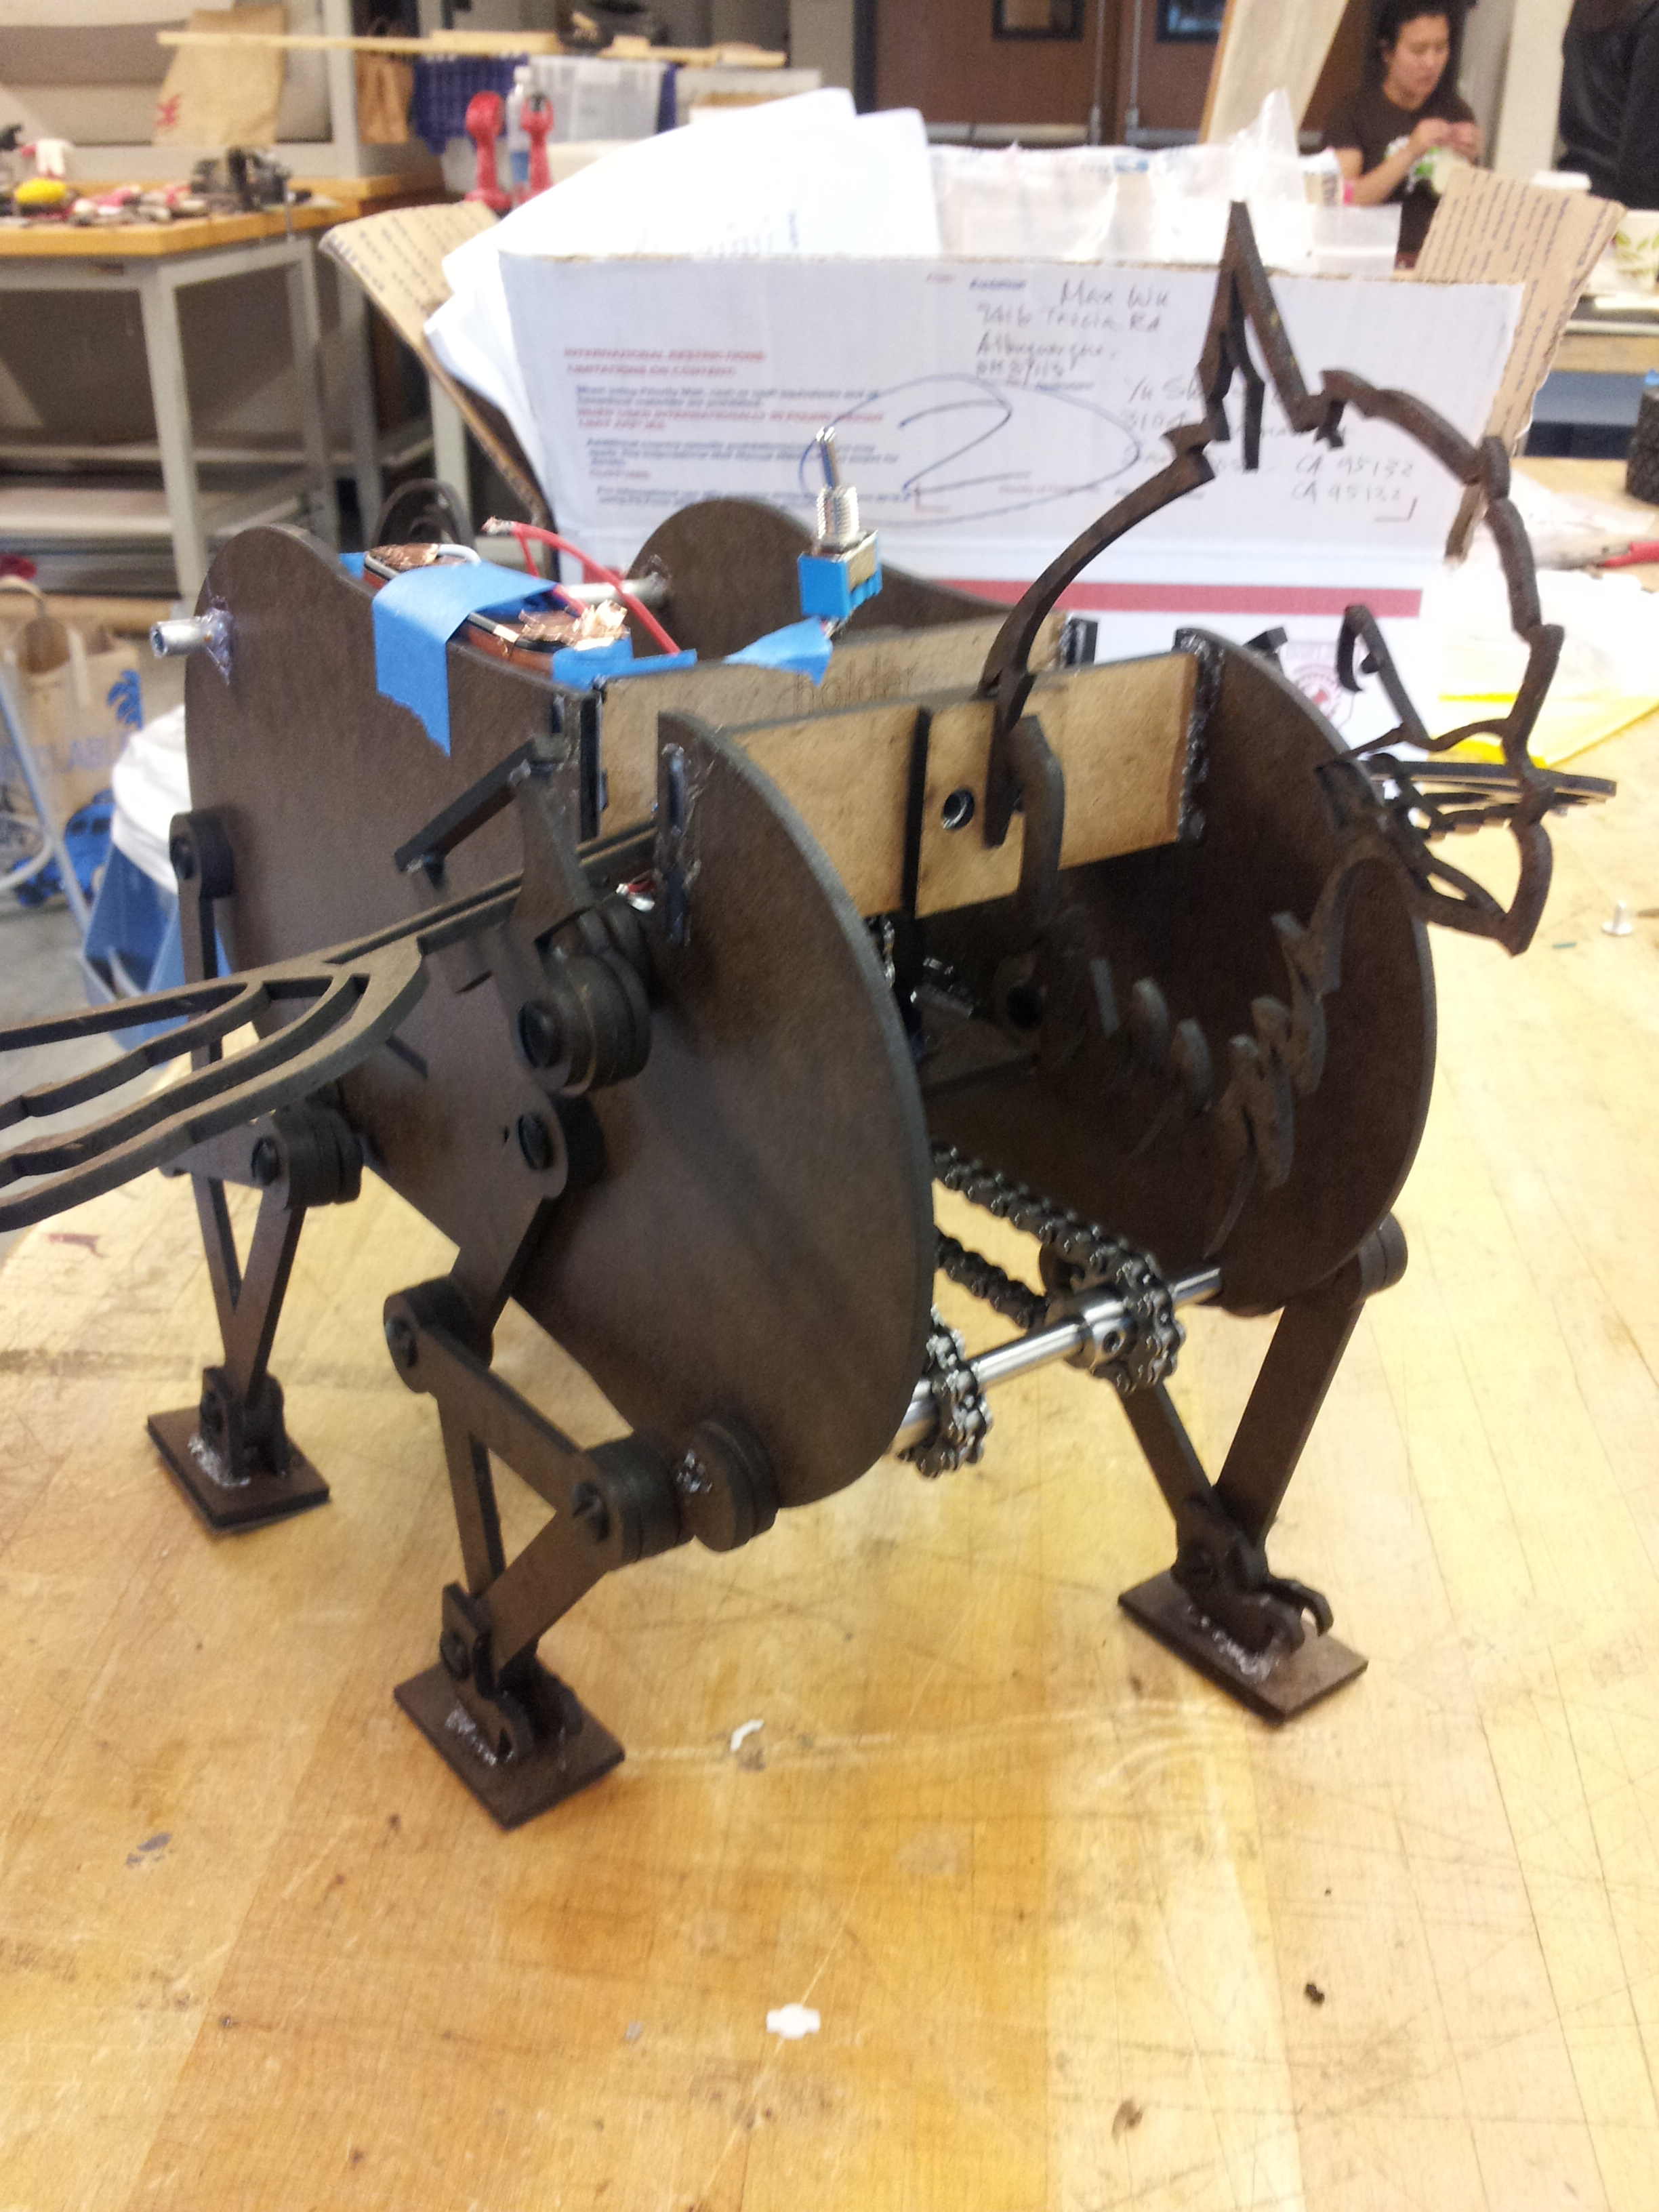We are very pleased with our hippogriff’s final design and performance (see Figure 7). As a result, we highly recommend that the Committee of Secrecy implement our design in Project Baby Got Beak to maintain the secrecy of the entire magical community.

**Figure 7 (right): Final hippogriff design**